Pet Clinic Web app with appointment, adoption, E-commerce, and simple automation

systems

2021-2022

Faculty Of Computer Engineering

Graduation Project Thesis

Rami Saad Al Deen | 2017710205029

Reem Alhalbouni | 2017710205052

**Pet Clinic Web app with appointment, adoption,   
E-commerce, and simple automation systems**

**Reem Alhalbouni**

**Rami Saad Al Deen**

**Karabük University**

**Engineering Faculty**

**Has been prepared as**

**a senior project thesis for**

**computer engineering department**

**KARABÜK**

**June 2022**

I certify that the project titled “Pet Clinic Web app with appointment, adoption, E-commerce, and simple automation systems” prepared by Rami Saad Al Deen and Reem Alhalbouni is suitable as a Graduation Project Thesis.

Assoc. Prof. Dr. İlhami Muharrem ORAK ..........................

Graduation Project Advisor, Department of Computer Engineering

....../….../2022

This thesis was approved by Computer Engineering department as a graduation project thesis.

Prof. Dr. Yüksel ÇELİK ..........................

Head of Computer Engineering department

*“All the information in this project is obtained and presented in accordance with academic rules and ethical principles; we further declare that we have made all attributions that do not originate in this work, as required by these rules and principles.”*

Reem Alhalbouni, Rami Saad Al Deen

# ABSTRACT

**Senior Project Thesis**

**Pet Clinic Web app with appointment, adoption,   
E-commerce, and simple automation systems**

**Rami Saad Al Deen  
Reem Alhalbouni**

**Karabuk University**

**Faculty Of Computer Engineering**

**Thesis’s Supervisor:**

**Assoc. Prof. Dr. İlhami Muharrem ORAK  
June 2022, xx pages**

This project in a nutshell is a Web app designed for a pet clinic where many services were introduced to serve the pet clinic's needs from making appointments and selling products, to providing an environment for users who are interested in pet adoption or those who are interested in putting their pets for adoption.

All previous services were designed alongside a simple automation system, and both are handled by the Web app.

**Keywords :** Web Application, Appointment System, E-commerce, Adoption System, Registration System, Account Management System, Submission and Adoption System, Frontend, Backend, Database, Relational Data Base, RD, SQL, Query, Agile, Scrum, Deployment Phase, Staff Panel, Admin Panel, Filtering System, Payment

# Thanks

We would like to express our endless thanks to our beloved professor **Dr. İlhami Muharrem ORAK** who accompanied us along the way, and provided us with guidance and support in planning, researching, execution and formation of this thesis.

His knowledge and experience were a huge enlightenment to us through college years and through this thesis.

# Contents

**Page**

ACCEPTANCE ii

ABSTRACT iv

THANKS v

CONTENTS vi

FIGURES INDEX vii

CHAPTER 1 8

INTRO 8

1.1. LITERATURE SUMMRY 8

1.2. PROJECT’S OBJECTIVE 11

CHAPTER 2 12

PROJECT'S SOFTWARE PROCESS MODEL 12

2.1. SCRUM MODEL 12

2..1.1. BACKLOG (USER STORIES) 14

2..1.1.1.The Intended System Use-case Diagrams 16

2..1.1.1.The Intended System Use-case Diagrams 16

2..1.1.1.The Intended System Conceptual ERD Diagram 24

2..1.1.1.The Intended System Physical ERD 25

2..1.2. PROJECT’S SPRINTS 30

2..1.2.1 FIRST SPRINT 30

2..1.2.2SECOND SPRINT 31

# FIGURES INDEX

**Page**

Figure 2.1. Scrum Model. 14

Figure 2..1.1. Site Concept Map. 15

Figure 2..1.1.1.A. Main System. 17

Figure 2..1.1.1.B. Registration System. 18

Figure 2..1.1.1.C. Appointment System.. 19

Figure 2..1.1.1.D. Adoption System. 20

Figure 2..1.1.1.E.Account Management System.. 21

Figure 2..1.1.1.F. Staff Panel. 22

Figure 2..1.1.1.G. Admin Panel. 23

Figure 2..1.2.1.H.e-commerce System 24

Figure 2..1.2.2.Conceptual ERD 25

Figure 2..1.2.3.Physical ERD 26

Figure 2..1.2.4. Physical ERD Modification 27

Figure 2..1.2.1.1. Signup Page Design 31

Figure 2..1.2.1.2. Login Page Design 31

Figure 2..1.2.1.3. Register Pet Page Design 32

Figure 2..1.2.2.1. Home Page Design 32

Figure 2..1.2.2.2. Appointment Page Design 33

Figure 2..1.2.2.3. Adoption Page Design 34

Figure 2..1.2.2.4. Adoption Ads Page Design 34

Figure 2..1.2.2.5. Adoption Ad Page Design 35

Figure 2..1.2.2.6. Manage User Profile Page Design 36

Figure 2..1.2.2.7. Manage Adoption Posts Page Design 36

Figure 2..1.2.2.8. Manage Pets Page Design 36

Figure 2..1.2.3..1 Staff Panel - Manage Adoption posts page Design 37

Figure 2..1.2.3.2. Staff Panel – Manage Appointment page design 37  
Figure 2..1.2.3.3. Staff Panel – Pet’s Treatment History 1 38

Figure 2..1.2.3.4. Staff Panel – Pet’s Treatment History 2 38  
Figure 2..1.2.3.5. Staff Panel – Update Pet’s Treatment History 1 39

Figure 2..1.2.3.6. Staff Panel – Add New Treatment History 2 39

Figure 2..1.2.3.7. Staff Panel – Registration 40

Figure 2..1.2.3.8. Staff Panel – Register A Client Page Design 40

Figure 2..1.2.3.9. Staff List Page Design 41

# CHAPTER 1

# INTRO

## 1.1. LITERATURE SUMMARY

Web applications are used in all aspects of life, and it has been a dependable tool for both governmental and private institutions and to provide an easy access interface for users.

For example, in the health field, using Web apps has become a common sense since Web apps give the users the ability to make appointments, check current and previous appointments and manage them, furthermore It allows them to preview their health records, tests results, x-rays...etc. Thus, Web apps help humans to easily keep track and take care of their health, similarly Web apps serve the health of pets since most pet clinics have leant towards using Web apps as an introductive interface which presents their services and shows the skillfulness of their staff.

Therefore, this project's main idea is to develop a Web app for a pet clinic which consists of the following main systems:

1. **Health related systems:**
2. Appointment System:

After doing research about pet's health related Web applications that are used in Turkey, and based on the services provided they can be categorized into two groups:

a) Web apps as search engines that can find the nearest pet clinic from the user's location and provide the ability to make an appointment based on the vet and their specialty, in addition these Web apps make it possible for the users to view the staff from multiple clinics and check vets' reviews (1)

b) Web apps that belong to pet clinics or pet hospitals and these apps focus on showcasing the clinic's or the hospital's services, branches, contact information, and location.

The mechanism used to make an appointment through these apps is either by contact information (phone number, email) or by submitting a form and sending it to the app(2)

In the Web app designed in this project the following modifications were implemented in the appointment system:

- In contrast to group **(a)** the appointment service is dedicated to only one clinic where the user can manage their appointments.

- In contrast to group (**b)** the appointment is made via the appointment system directly instead of using form, contact info...etc.

- the feature of making an appointment for pet training has been added.

1. Registration System:

The majority of the Web apps included in the research don't have a registration system which gives users the ability to sign up, sign in, and get access to the rest of the Web app's services. (3)

Some of the apps that has a registration system (4) lacks the feature of signing up the pet to the database which helps in creating an identity for the pet and this identity can be used later to monitor pet's health record and in other services such as adoption system, whereas in this project this feature has been added and is available for the users.

**2) Adoption System**

After making research about the Web apps that are specialized in adopting pets, it turned out that traditionally the adoption system is as follows:

The pet owner submits an adoption ad which includes pet's information and the contact method which is either by messaging via the Web app or by commenting on the ad itself. (5)

In this project the adoption system works by sending the contact information from the pet owner to the pet requester, furthermore when posting an adoption ad, the feature of including the pet training record and the pet info to the post is added.

In this project it is assumed that the targeted clinic has its own shelter for this reason the app was designed to allow the clinic to add adoption ads of the shelter's pets.

**3) E-commerce System**

In the e-commerce system it was assumed that the clinic has products that can be bought through the Web app, and the system is a simplified version of the most traditional e-commerce apps. (6)

**4) Automation System**

Similar to the need for a Web app that serves the pet's health and provide the previously mentioned services, there is also a need for a simple automation system in the clinic itself that can be used by the staff members, and this system will be integrated into the Web app system.

## 1.2. PROJECT’S OBJECTIVE

This project assumes that there is a pet clinic in Karabük city in Turkey, the clinic requires its own Web app with the following systems:

1- Appointment System

2- Registration System

3- Adoption System

4- E-commerce System

5- Automation System

The above systems would make the clinic's business easier, more user-friendly, and organized for both the clinic's staff and the clients who visit the clinic.

The adoption system in Karabük also lacks some form of regulation since most adoption offers are posted via social media such as Instagram and Facebook. which makes the adoption process unorganized and not easily found for most adopters.

Therefore, there's a need for an adoption system that can be managed by the clinic's Web app which benefits those who are interested, helps making the adoption process easier and most importantly helps in providing a faster way to find homes for pets.

The e-commerce system also helps in purchasing products for the pets which benefits both the clinic's business and its clients.

Since most of the above systems are done via the Web app of the clinic, there is a need to integrate them into an automation system that can be used in the clinic itself on the same Web app for all operations to be in synchronization.

Lastly, having all these systems and services in one place and handling them through one Web app is beneficial, and would make taking care of pets much easier and convenient.

# CHAPTER 2

# PROJECT'S SOFTWARE PROCESS MODEL

## 2.1. Scrum Model

What is the scrum model? (Figure 2.1)

Scrum is an agile development methodology used in the development of Software based on an iterative and incremental processes. Scrum is adaptable, fast, flexible, and effective agile framework that is designed to deliver value to the customer throughout the development of the project. (7) This project was developed using the scrum model because it:

1. Easily Scalable:

Scrum processes are iterative and are handled within specific work periods, which makes it easier for the team to focus on definite functionalities for each period.

1. Compliance of expectations:

The client establishes their expectations indicating the value that each requirement/ history of the project brings, the team estimates them and with this information the Product Owner establishes its priority.

1. Flexible to changes:

Quick reaction to changes in requirements generated by customer needs or market developments. The methodology is designed to adapt to the changing requirements that complex projects entail.

1. Reduction of risks:

The fact of carrying out the most valuable functionalities in the first place and of knowing the speed with which the team advances in the project, allows to clear risks effectively in advance. (7)

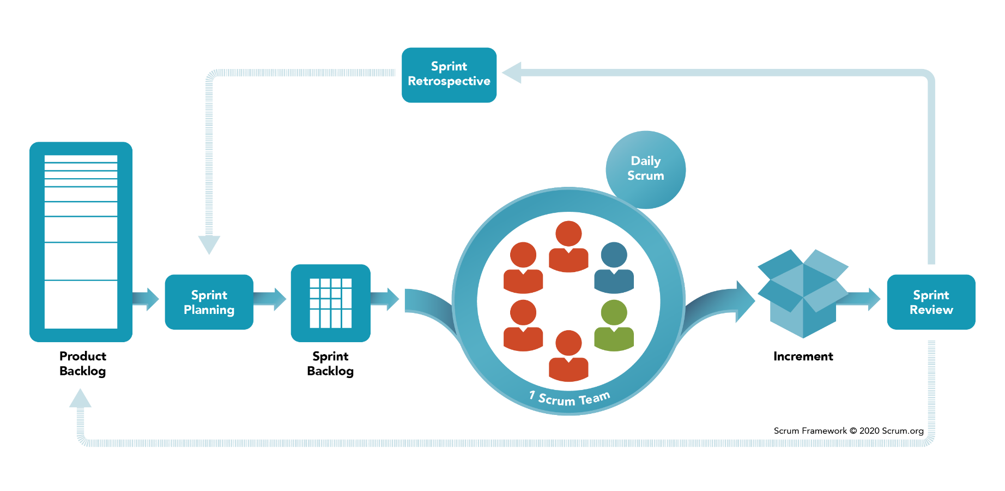Figure 2.1. Scrum Model.

#### 2..1.1. Backlog (User Stories):

Based on user stories (project’s requirements), a Site Concept Map was created to summarize the main and the secondary services that clinic's Web app will provide (Figure 2..1.1).

Figure 2..1.1 Site Concept Map

The project's services can be divided to two main categories:

1. Main Services:

Which can be divided to 4 systems:

1. Appointment System
2. Adoption System
3. Registration System
4. Automation System

The above systems’ sprints will be explained in the next part.

1. Secondary Services:

These services are complementary and helpful to the users of the system.

The project consists of 4 secondary services:

1. Articles: which can be read by pet lovers to get beneficial information about pet's health, behavior, and insights.
2. Staff List: Users usually tend to checkout the review about a certain doctor or a staff member to make sure to get the best treatment available.
3. Helpful Links:
4. E-commerce:

For this project all the required technologies were discussed and can be divided to:

Front-end part:

- HTML5

- CSS

- SASS

- JavaScript / jQuery

- AJAX

- Bootstrap

- React

back-end / server-side part:

- JavaScript / Node.js

Database:

- Relational Databases / SQL

##### 2..1.1.1. The Intended System Use-case Diagrams:

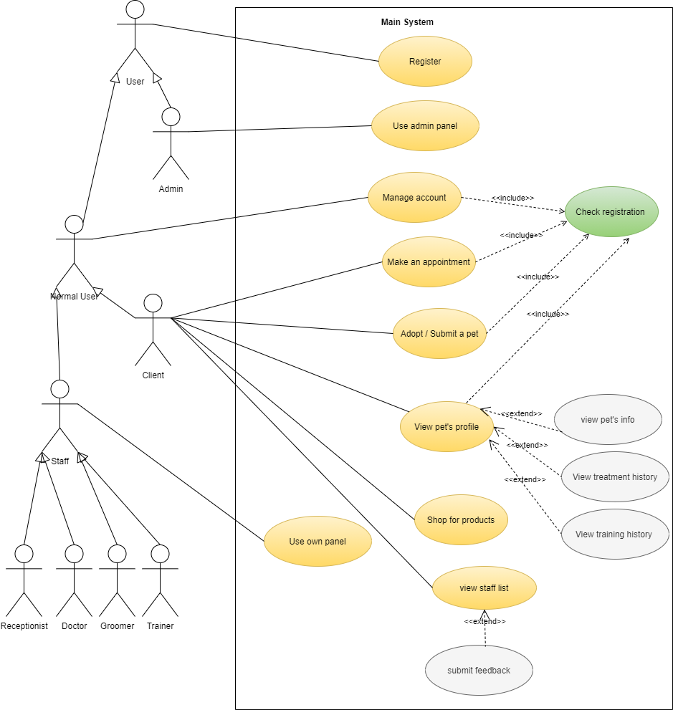Figure 2..1.1.1. A. Main System:

Figure 2..1.1.1. B. Registration System:

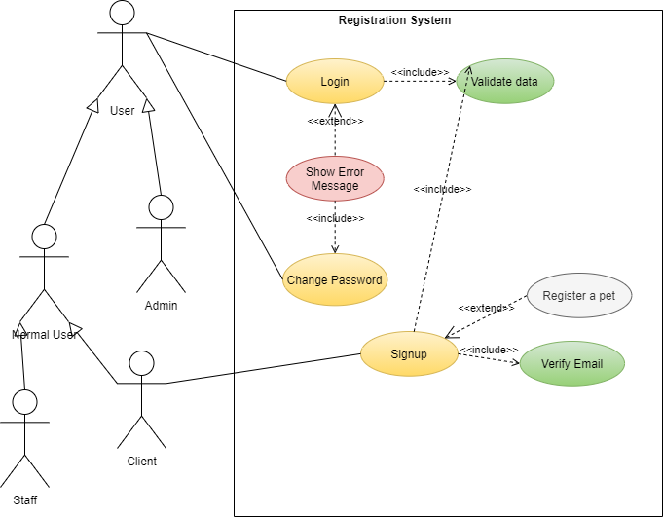

Figure 2..1.1.1. C. Appointment System:

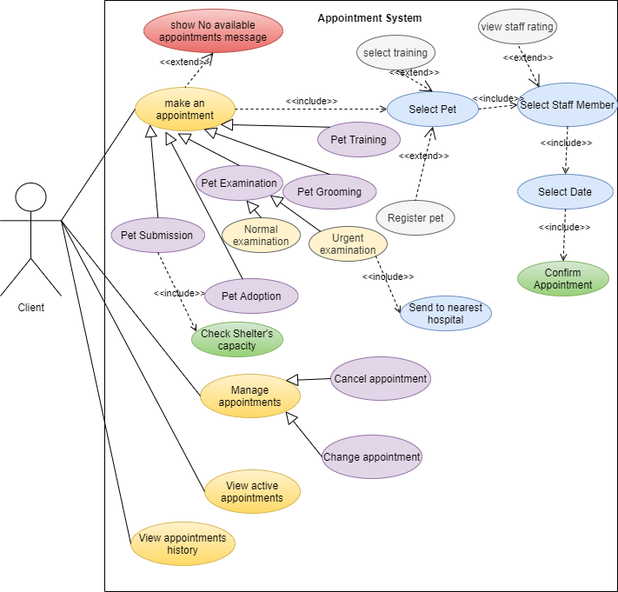

Figure 2..1.1.1. D. Adoption System:

Figure 2..1.1.1. E. Account Management System:

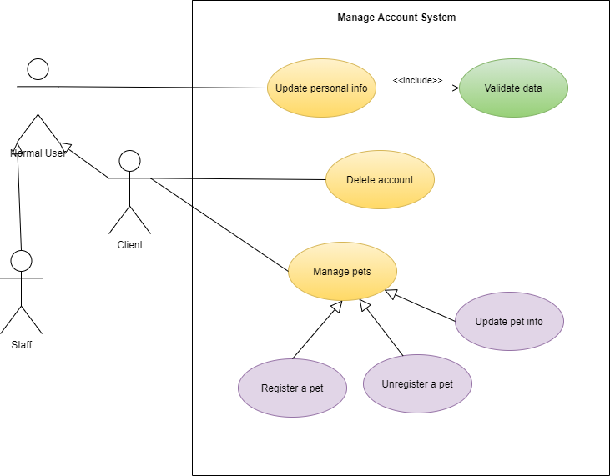

Figure 2..1.1.1. F. Staff Panel:

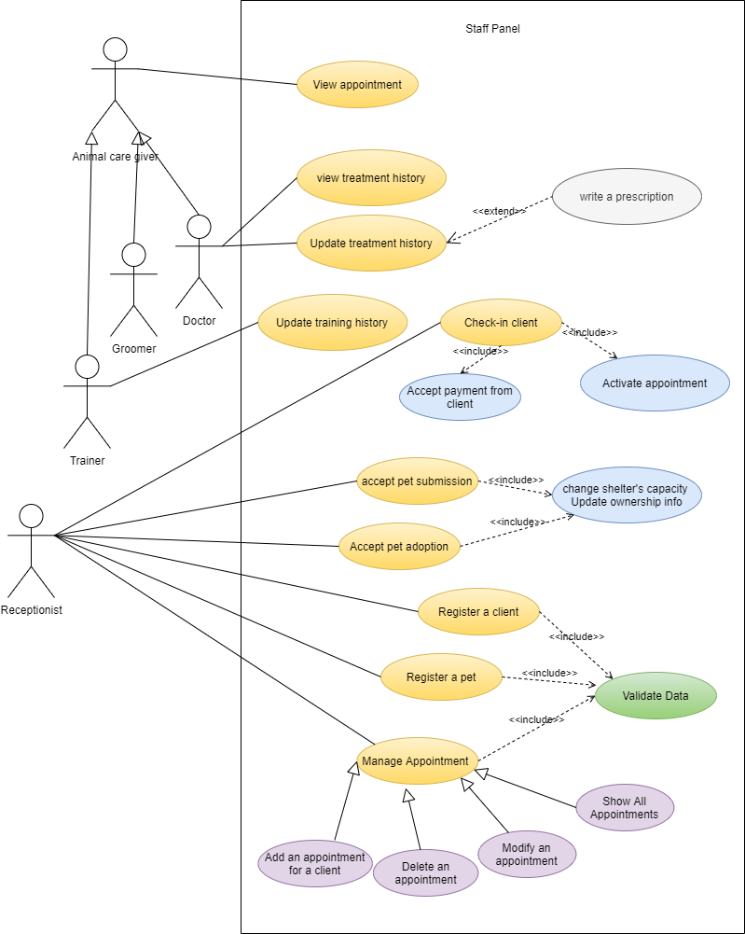

Figure 2..1.1.1. G. Admin Panel:

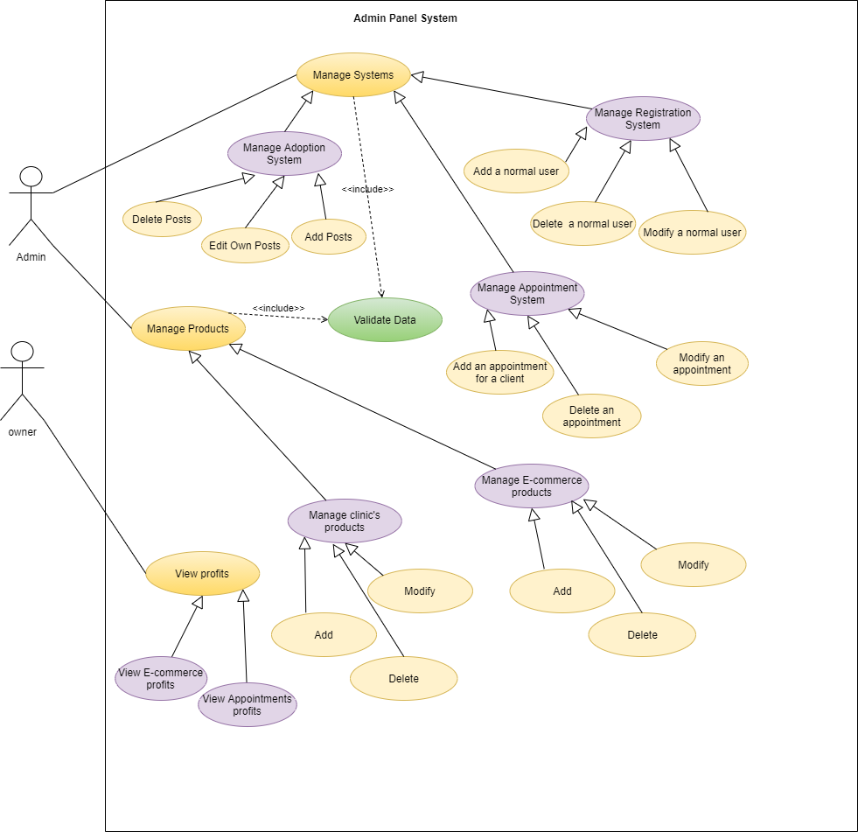

Figure 2..1.1.1. H. E-commerce System:

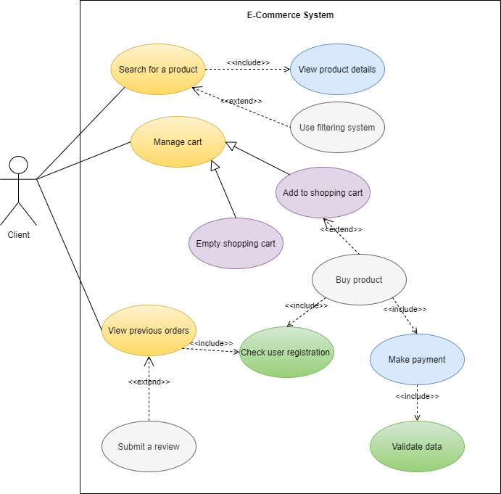

##### 2..1.1.2 The intended system’s conceptual ERD diagram

Conceptual ERD models information gathered from business requirements.  
Entities and relationships modeled in such ERD are defined around the business's need.

The need of satisfying the database design is not considered yet.  
Conceptual ERD is the simplest model among all.

Figure 2..1.1.2. ERD diagram

##### 2..1.1.3 The intended system’s physical ERD

Physical ERD represents the actual design of database. It deals with conversion from logical design into a schema level design that will be transformed into relational database. When modeling a physical ERD, Logical ERD is treated as base, refinement occurs by defining primary keys, foreign keys and constraints.

Figure 2..1.1.3. physical ERD

Later, the following modification was done on the tables that represent the entities treatment and prescription:  
  
  
  
  
  
  
  
  
 Figure 2..1.1.4. physical ERD modification

Then, creation of the database was done via mysql statements.

The following is a sample of the code used to create one of the tables, the pets table, with its constraints and foreign keys:

CREATE TABLE `PETS` (

`id` INT NOT NULL AUTO_INCREMENT,

`name` VARCHAR(150) NOT NULL,

`gender` VARCHAR(150) NOT NULL,

`birth_date` DATETIME NOT NULL,

`breed_name` VARCHAR(150) NOT NULL,

`photo` MEDIUMBLOB,

`pervious_owner` INT,

`shelter_id` INT,

`owner_id` INT,

PRIMARY KEY (`id`)

);

ALTER TABLE `PETS` ADD CONSTRAINT `PETS_fk0` FOREIGN KEY (`breed_name`) REFERENCES `BREEDS`(`name`);

ALTER TABLE `PETS` ADD CONSTRAINT `PETS_fk1` FOREIGN KEY (`shelter_id`) REFERENCES `SHELTERS`(`id`);

ALTER TABLE `PETS` ADD CONSTRAINT `PETS_fk2` FOREIGN KEY (`owner_id`) REFERENCES `USERS`(`id`) ON DELETE CASCADE;

Since the database contained arcs, subtypes and supertypes there was a need for check constraints as the following:

ALTER TABLE `prescriptions` ADD CONSTRAINT `PRESCRIPTIONS_fk2` FOREIGN KEY (`pet_id`) REFERENCES `treatments`(`pet_id`) ON DELETE CASCADE

ALTER TABLE `prescriptions` ADD CONSTRAINT `PRESCRIPTIONS_fk1` FOREIGN KEY (`doctor_id`) REFERENCES `treatments`(`doctor_id`) ON DELETE CASCADE

ALTER TABLE `prescriptions` ADD CONSTRAINT `PRESCRIPTIONS_fk0` FOREIGN KEY (`treatment_date`) REFERENCES `treatments`(`date`) ON DELETE CASCADE

ALTER TABLE `adoption_ads` ADD CONSTRAINT arc_adoption_ad CHECK (shelter_id is NULL OR client_id is NULL);

ALTER TABLE `pets` ADD CONSTRAINT arc_pet CHECK (shelter_id is NULL OR owner_id is NULL);

ALTER TABLE `users` ADD CONSTRAINT users_subtypes CHECK ((user_type = "client" AND stmem_type is NULL ) or (user_type = "stmem" AND stmem_type is not NULL) );

To make sure the database was modeled and designed correctly, some tests were done. Here is an example:

The following query, returns all the appointments done in the pet clinic with its relative data, such as the doctor’s name, client’s name, pet’s name, the date of the appointment, its fee and its type.

The result was as following:

Another example:

This query returns all the relative data that shows all the pets in the database with their training, treatment, name, breed, and type.

The result was as the following:

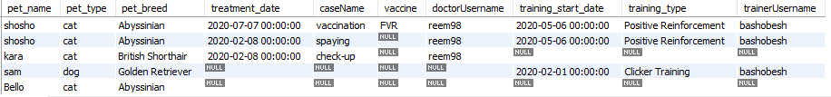

#### 2..1.2. Project’s Sprints:

##### 2..1.2.1 First Sprint:

In this sprint the following front-end pages were designed:

Figure 2..1.2.1.1 Signup page design

Figure 2..1.2.1.2 Login page design

Figure 2..1.2.1.3 Register pet design

##### 2..1.2.2 Second Sprint:

Figure 2..1.2.2.1 Home page design

Figure 2..1.2.2.2 Appointment page

Figure 2..1.2.2.4. Adoption ads page

Figure 2..1.2.2.3 Adoption page

Figure 2..1.2.2.5. Adoption ad page

Figure 2..1.2.2.6. My profile page design

Figure 2..1.2.2.7. Manage adoption posts page design

Figure 2..1.2.2.8. Manage pets page design

Figure 2..1.2.2.8. Manage pets page design

Figure 2..1.2.2.6. Manage user’s profile

##### 2..1.2.3 Third sprint:

In this sprint the following front-end pages were designed:

Figure 2..1.2.3.2 Staff Panel, manage appointments

Figure 2..1.2.3.1 Staff Panel, manage adoption requests

Figure 2..1.2.3.3 Staff Panel, pet’s treatment history 1

Figure 2..1.2.3.4 Staff Panel, pet’s treatment history 2

Figure 2..1.2.3.5 Staff Panel, update treatment history

Figure 2..1.2.3.6 Staff Panel, add new treatment

Figure 2..1.2.3.8 Staff Panel, register client

Figure 2..1.2.3.7 Staff Panel, registration

Figure 2..1.2.3.9 Staff List Page Design

# References

1. Vet Randevu [www.vetrandevu.com](http://www.vetrandevu.com)
2. Vet House <https://www.vethouse.com.tr/>

Hayvan Hastanesi [http://hayvanhastanesi.veterinary.ankara.edu.tr](http://hayvanhastanesi.veterinary.ankara.edu.tr/)

1. Vet House <https://www.vethouse.com.tr/>

Vet Dentist Istanbul <http://vetdentistanbul.com/randevu/>

1. Vet Randevu <https://www.vetrandevu.com/>
2. Sahibim olur musun , <https://sahibimolurmusun.com/>

Pet Surfer <https://petsurfer.com/ilan-liste/tum>

1. Zoo , <https://www.zoo.com.tr/>

Petzz Shop <https://www.petzzshop.com/>

Ilan Kimden <https://www.ilankimden.com/ps/793/kopek-bakim-urunleri/>

1. [What Is Scrum Methodology? & Scrum Project Management (digite.com)](https://www.digite.com/agile/scrum-methodology/#:~:text=Scrum%20is%20an%20agile%20development,the%20development%20of%20the%20project.)
2. <https://www.lucidchart.com/blog/pros-and-cons-of-waterfall-methodology/>